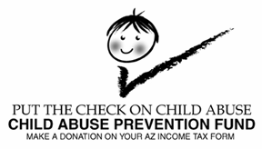

2016 Income Tax Check-off Campaign

ENCLOSED IS THE FOLLOWING INFORMATION:

**GENERAL INFORMATION**

1. Child Abuse Prevention (CAP) Fund fact sheet
2. A list of commonly asked questions and answers about the CAP Fund
3. Child Abuse Prevention Fund Revenue Sources from 1983 to 2015

Please feel free to use any of the information found in the attached as you prepare your campaign.

**PUBLIC SERVICE ANNOUNCEMENT MATERIALS:**

1. Speech appropriate for the general public
2. Speech appropriate for income tax preparers
3. Letter to be sent to tax preparers
4. Cover letter to be sent to radio stations and two radio PSA’s
5. Letter to be typed on your Council’s stationary to be sent to local newspapers along with a copy of the paycheck stuffer, Check-Off logos, 3 Kids logo and CAP Fund logos.
6. E-mail you can send to Arizona residents asking them to donate on their AZ state tax form

Please customize the attached speeches and letters prior to delivering it to members of your community.



**T**he Child Abuse Prevention Fund was established by the legislature in 1982



**T**he purpose of the Fund is to promote child abuse prevention and to provide financial assistance to community agencies for the prevention of child abuse



**T**he Fund receives its revenue from the following sources:



1. The income tax check off on the Arizona tax form
2. A percentage of the surcharges on fees for marriage licenses, dissolutions, and death certificates
3. Private donations.

**\*S**ince FY 1982, over 18 million has been collected and 50 different programs have been funded providing services to Arizona’s children and families in the following areas. Not all programs are funded every year. Each year different programs are funded.*



1. Healthy Families Arizona home visiting program and evaluation*
2. In-Home Services*
3. Annual Child Abuse Prevention Conference
4. Regional Child Abuse Prevention Councils
5. First Steps Programs
6. Teen and adult parenting education
7. Child sexual abuse prevention
8. In-Home Services and Parent Aide programs
9. Support groups for parents
10. Telephone reassurance for latchkey children
11. Child abuse prevention education programs

*During 2010 and 2011, all of the money raised from the income tax check off went to support the Healthy Families Arizona program, which has sites all over the State. For more information about Healthy Families Arizona program please go to: <https://www.azdes.gov/PreventionAndFamilySupport/>.

*The money raised between 2012 and 2015 supported the In-Home Services Program (<https://www.azdes.gov/PreventionAndFamilySupport/>).



**QUESTIONS AND ANSWERS ABOUT THE CAP FUND**

**HOW DOES THE CAP FUND RECEIVE MONEY?**

The Fund gets money from several sources: The donation option located on the Arizona state income tax form, from a percentage of the surcharges from marriage licenses, dissolutions, and death certificates and private donations.

**HOW MUCH MONEY IS USED FOR ADMINISTRATIVE PURPOSES?**

The law allows for only 5% of the CAP Fund to be used for administrative purposes.

**HOW CAN ORGANIZATIONS APPLY FOR CAP FUND MONIES?**

A Request for Proposal process is utilized when soliciting proposals for child abuse prevention programs. The State of Arizona procurement code is followed during the entire solicitation and awards process.

**WHO MAKES THE FUNDING DECISIONS?**

An evaluation panel, which includes members of the community, is chosen to evaluate proposals and make funding recommendations to the Director of the Arizona Department of Economic Security (which has since changed to the Department of Child Safety) who by law has the final authority over the Fund.

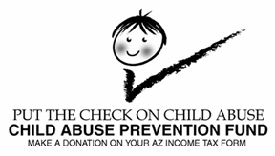

**REVENUE SOURCES**

| **YEAR** | **SURCHARGE/ COURT FEES\*** | **TAX CHECK OFF** | **DONATIONS** | **ASECC** | **NOTARY**  **FEES\*** | **TOTAL** |
| --- | --- | --- | --- | --- | --- | --- |
| 1983 | 113,156 |  |  |  |  | 113,156 |
| 1984 | 151,153 | 23,041 |  |  |  | 174,194 |
| 1985 | 183,277 | 150,154 |  |  |  | 333,431 |
| 1986 | 221,835 | 253,408 |  |  |  | 475,243 |
| 1987 | 190,504 | 278,754 |  |  |  | 469,258 |
| 1988 | 189,884 | 253,217 |  |  |  | 443,101 |
| 1989 | 186,641 | 281,996 |  |  |  | 468,637 |
| 1990 | 195,173 | 273,956 | 854 |  |  | 469,983 |
| 1991 | 234,532 | 188,007 | 8 |  |  | 422,547 |
| 1992 | 271,775 | 210,632 | 105 | 1,602 |  | 484,114 |
| 1993 | 273,975 | 169,589 | 2,163 | 7,356 |  | 453,083 |
| 1994 | 281,648 | 171,568 | 1,106 | 12,870 | 114,224 | 581,416 |
| 1995 | 293,035 | 177,782 | 550 | 14,813 | 162,290 | 648,470 |
| 1996 | 292,184 | 195,308 | 75 | 11,610 | 106,873 | 606,050 |
| 1997 | 354,866 | 192,551 | 40 | 20,864 | 192,931 | 761,252 |
| 1998 | 316,163 | 223,435 | 0 | 18,161 | 161,738 | 719,497 |
| 1999 | 323,377 | 210,355 | 331 | 22,150 | 169,383 | 725,596 |
| 2000 | 296,346 | 185,666 | 928 | 29,721 | 79,419 | 592,080 |
| 2001 | 300,625 | 222,325 | 72 | 35,585 | 288,779 | 847,386 |
| 2002 | 298,086 | 210,223 | 0 | 32,518 | 249,106 | 789,933 |
| 2003 | 310,090 | 202,941 | 0 | 0 | 153,866 | 666,897 |
| 2004 | 327,962 | 198,467 | 600 | 0 | 300,070 | 827,099 |
| 2005 | 322,988 | 200,870 | 0 | 0 | 161,965 | 685,823 |
| 2006 | 326,044 | 240,323 | 0 | 0 | 335,420 | 901,787 |
| 2007 | 341,655 | 250,683 | 0 | 0 | 147,364 | 739,702 |
| 2008 | 356,571 | 260,062 | 0 | 0 | 147,559 | 764,192 |
| 2009 | 471,809 | 232,949 | 0 | 0 | 5,522 | 710,280 |
| 2010 | 555,148 | 220,098 | 0 | 0 | 6,195 | 781,441 |
| 2011 | 535,714 | 159,694 | 0 | 0 | 7,403 | 702,811 |
| 2012 | 514,208 | 156,194 | 0 | 0 | 4,649 | 675,051 |
| 2013 | 498,262 | 158,556 | 0 | 0 | 7,989 | 664,807 |
| 2014 | 495,286 | 169,281 | 0 | 0 | 5,470 | 670,037 |
| 2015 | 458,303 | 172,806 | 0 | 0 | 3,903 | 635,012 |
| **TOTAL** | **10,482,275** | **6,494,891** | **6,832** | **207,250** | **2,812,118** | **20,003,366** |

*After 2008, death fees were moved from the NOTARY FEES column into the SURCHARGE column (which collects court fees from marriages and divorces). The DEATH FEES column was renamed NOTARY FEES.

**SPEECH APPROPRIATE FOR THE GENERAL PUBLIC**

Child abuse is a problem in Arizona. Child abuse is a problem in Arizona. In state fiscal year 2015 there were 51,075 reports of abuse and neglect involving 81,068 children. Prevention is the only way to reverse this alarming trend.

|  |
| --- |
| In state fiscal year 2014 there were 45,931 reports of abuse and neglect involving over 61,095 children. |

The Child Abuse Prevention Fund, established by the Arizona legislature in 1982, provides financial assistance to community agencies for child abuse prevention programs. Although it is a statewide program, no state dollars are appropriated.

Individual taxpayers in Arizona have a unique opportunity to help prevent child abuse by making a donation to the Child Abuse Prevention Fund on their individual income tax return. Whether they get a refund or make a payment, they can still donate.

Since 1982, over $18 million dollars has been collected and 50 different prevention programs have been funded including teen and adult parenting education, child sexual abuse prevention, support groups for parents, First Steps programs, annual child abuse prevention conference, Regional Child Abuse Prevention Councils, and Healthy Families Arizona programs and evaluation. Healthy Families Programs have proven dramatically effective in educating parents and keeping children safe from child abuse and neglect.

**PERSONALIZE THE SPEECH BY SAYING SOMETHING LIKE THE FOLLOWING:**

I live in this community with you and know that child abuse is a growing problem... right here where we live. We all need to work together to help prevent the tragedy of child abuse. The Child Abuse Prevention Fund funds programs that work to prevent child abuse. For every dollar spent on prevention services, six to ten dollars is saved in social costs. The Child Abuse Prevention Fund is funding programs right here in our community.

**GO INTO DETAIL ABOUT YOUR PROGRAM**

I am asking you, as a member of this community, to join in the fight to stop child abuse. Your help will absolutely make a difference this tax season. Please join the effort to help put the check on child abuse.

**SPEECH TO BE GIVEN TO INCOME TAX PREPARERS**

Child abuse is a problem in Arizona. Child abuse is a problem in Arizona. In state fiscal year 2015 there were 51,075 reports of abuse and neglect involving 81,068 children. Prevention is the only way to reverse this alarming trend.

The Child Abuse Prevention Fund, established by the Arizona legislature in 1982, provides financial assistance to community agencies for child abuse prevention programs. Although it is a statewide program, no state dollars are appropriated.

Since 1982, over $18 million dollars has been collected and 50 different prevention programs have been funded including teen and adult parenting education, child sexual abuse prevention, support groups for parents, First Steps programs, annual Child Abuse Prevention Conference, Regional Child Abuse Prevention Councils, and Healthy Families Arizona Programs and evaluation. Healthy Families Programs have proven dramatically effective in educating parents and keeping children safe from child abuse and neglect.

You are in a unique position. Over one half of all taxpayers rely upon you and your colleagues for help when they file their taxes. You certainly won't guess at what figures to enter on your client's tax form...please...don't make a guess about whether they want to make a donation...ask them! Advising your client about the donation option allows them the opportunity to make an informed choice. Whether they get a refund or make a payment, they can still donate.

Please make the donation option more visible by listing it in the questionnaire you send out or just ask your client directly if they would like to make a donation. It has never been easier to make such a positive difference in the life of a child.

**PERSONALIZE THE SPEECH BY SAYING SOMETHING LIKE THE FOLLOWING:**

I live in this community with you and know that child abuse is a growing problem... right here where we live. We all need to work together to help prevent the tragedy of child abuse. The Child Abuse Prevention Fund funds programs that work to prevent child abuse. For every dollar spent on prevention services, six to ten dollars is saved in social costs. The Child Abuse Prevention Fund is funding programs right here in our community.

**GO INTO DETAIL ABOUT YOUR PROGRAM** (that the CAP Fund is currently funding or has funded in the past).

I am asking you, as a member of this community, to join in the fight to stop child abuse. Your help will absolutely make a difference this tax season. Please join the effort to help put the check on child abuse.

**SAMPLE LETTER TO BE SENT TO TAX PREPARERS IN YOUR COMMUNITY**

DATE

Tax Preparer

Any Town, Arizona

Dear Tax Preparer:

Child abuse is a problem in Arizona. Child abuse is a problem in Arizona. In state fiscal year 2015 there were 51,075 reports of abuse and neglect involving 81,068 children. Prevention is the only way to reverse this alarming trend.

The Child Abuse Prevention Fund, established by the Arizona legislature in 1982, provides financial assistance to community agencies for child abuse prevention programs. Although it is a statewide program, no state dollars are appropriated to it. The Fund relies heavily upon donations by individual taxpayers on the Arizona state tax form.

Since 1982, over $18 million dollars has been collected and 50 different prevention programs have been funded including teen and adult parenting education, child sexual abuse prevention, support groups for parents, First Steps programs, annual child abuse prevention conference, Regional Child Abuse Prevention Councils, and Healthy Families Arizona Programs and evaluation. Healthy Families Programs have been proven dramatically effective in educating parents and keeping children safe from child abuse and neglect.

You are in a unique position. Over one half of all taxpayers rely upon you and your colleagues for help when they file their taxes. You certainly won't guess at what figures to enter on your clients' tax form...please...don't make a guess about whether they want to make a donation...ask them! Advising your client about the donation option allows them the opportunity to make an informed choice. Whether they get a refund or make a payment, they can still donate.

Please make the donation option more visible by listing it in the questionnaire you send out or just ask your client directly if they would like to make a donation. It has never been easier to make such a positive difference in the life of a child.

I live in this community with you and know that child abuse is a growing problem... right here where we live. We all need to work together to help prevent the tragedy of child abuse. The Child Abuse Prevention Fund funds programs that work to prevent child abuse. For every dollar spent on prevention services, six to ten dollars is saved in social costs. The Child Abuse Prevention Fund is funding programs right here in our community.

I am asking you, as a member of this community, to join in the fight to stop child abuse. Your help can absolutely make a difference this tax season. Please join the effort to help put the check on child abuse.

If you have any questions, please call me at *********.

Sincerely,

Jane Doe

|  |  |
| --- | --- |
| Child Abuse is a tough problem.  Helping to prevent it is easy.  Not enough people know that you can add money to your AZ tax return that will go straight into the Child Abuse Prevention Fund.  This special fund supports community programs in Arizona, like Healthy Families, that have proven effective in educating parents and keeping children safe.  The rewards are obvious; no child deserves to be physically abused or neglected. | What’s more, child abuse prevention pays off in the long term. For every dollar spent on prevention services, six to ten dollars is saved in social costs.  Please, make a donation to the Child Abuse Prevention Fund on your AZ tax return. It’s so little to ask and so easy to do. |
|  |  |

**Help Prevent Child Abuse. Make a donation on your AZ State Tax Return.**

|  |  |
| --- | --- |
| Child Abuse is a tough problem.  Helping to prevent it is easy.  Not enough people know that you can add money to your AZ tax return that will go straight into the Child Abuse Prevention Fund.  This special fund supports community programs in Arizona, like Healthy Families, that have proven effective in educating parents and keeping children safe.  The rewards are obvious; no child deserves to be physically abused or neglected. | What’s more, child abuse prevention pays off in the long term. For every dollar spent on prevention services, six to ten dollars is saved in social costs.    Please, make a donation to the Child Abuse Prevention Fund on your AZ tax return. It’s so little to ask and so easy to do. |

**Help Prevent Child Abuse. Make a donation on your AZ State Tax Return.**

|  |  |
| --- | --- |
| Child Abuse is a tough problem.  Helping to prevent it is easy.  Not enough people know that you can add money to your AZ tax return that will go straight into the Child Abuse Prevention Fund.  This special fund supports community programs in Arizona, like Healthy Families, that have proven effective in educating parents and keeping children safe.  The rewards are obvious; no child deserves to be physically abused or neglected. | What’s more, child abuse prevention pays off in the long term. For every dollar spent on prevention services, six to ten dollars is saved in social costs.    Please, make a donation to the Child Abuse Prevention Fund on your AZ tax return. It’s so little to ask and so easy to do. |

**Help Prevent Child Abuse. Make a donation on your AZ State Tax Return.**

**COVER LETTER TO BE SENT TO RADIO STATIONS AND TWO RADIO PSA’S**

DATE

Dear Public Service Director:

The enclosed PSA’s urge taxpayers to contribute to the Child Abuse Prevention Fund when completing their state income tax form.

This special Fund supports community programs in Arizona, like Healthy Families, that have proven effective in educating parents and keeping children safe.

Our REGIONAL CHILD ABUSE PREVENTION COUNCIL (FILL IN THE NAME OF YOUR COUNCIL) would appreciate it very much if you would air these spots as frequently as your schedule allows between now and the April 15 tax deadline.

Thank you for your help.

Sincerely,

Jane Doe

Regional Prevention Council

Phone number

**SAMPLE RADIO PSA:**

Child abuse is a problem in Arizona. In state fiscal year 2015 there were 51,075 reports of abuse and neglect involving 81,068 children. If, you think there’s nothing you can do about it, you’re wrong. On your Arizona state income tax form, you can contribute to the child abuse prevention fund. The fund supports programs working to keep children safe. Give a little. Help a lot!

**LETTER TO BE TYPED ON YOUR COUNCIL’S STATIONARY TO BE SENT TO LOCAL NEWSPAPERS ALONG WITH A COPY OF THE PAYCHECK STUFFER, CHECK-OFF LOGOS, 3 KIDS LOGO AND CAP FUND LOGOS.**

DATE

Newspaper

xxxxxxxx

xxxxxxxx

On behalf of the (fill in with your council name) Regional Prevention Council we would like to encourage you to publish the enclosed ads (PSA's) educating taxpayers about the opportunity to help prevent child abuse in Arizona.

Child abuse is a problem in Arizona. Child abuse is a problem in Arizona. In state fiscal year 2015 there were 51,075 reports of abuse and neglect involving 81,068 children. Prevention is the only way to reverse this alarming trend.

The Child Abuse Prevention Fund receives money from the income tax check off option located on the Arizona income tax form. This money is used to fund child abuse prevention programs throughout the state including programs right here in our community.

For every dollar spent on prevention services, six to ten dollars is saved in social costs. It is imperative that individual taxpayers know they have the ability to prevent child abuse by making a donation to the Fund on their tax form.

I am asking you, as a member of this community, to join in the fight to stop child abuse. Your help will make a difference this tax season.

If you have any questions about our Regional Prevention Council or the Child Abuse Prevention Fund, please call me at xxxxxxxxxxx.

Sincerely,

Jane Doe

Regional Prevention Council

Phone number

|  |  |
| --- | --- |
|  | **You can help prevent child abuse by making a donation to the Child Abuse Prevention Fund on your AZ State Tax Return form**. |
|  |  |
|  | **You can help prevent child abuse by making a donation to the Child Abuse Prevention Fund on your AZ State Tax Return form**. |
|  |  |
|  | **You can help prevent child abuse by making a donation to the Child Abuse Prevention Fund on your AZ State Tax Return form**. |
|  |  |
|  | **You can help prevent child abuse by making a donation to the Child Abuse Prevention Fund on your AZ State Tax Return form**. |
|  |  |
|  | **You can help prevent child abuse by making a donation to the Child Abuse Prevention Fund on your AZ State Tax Return form**. |

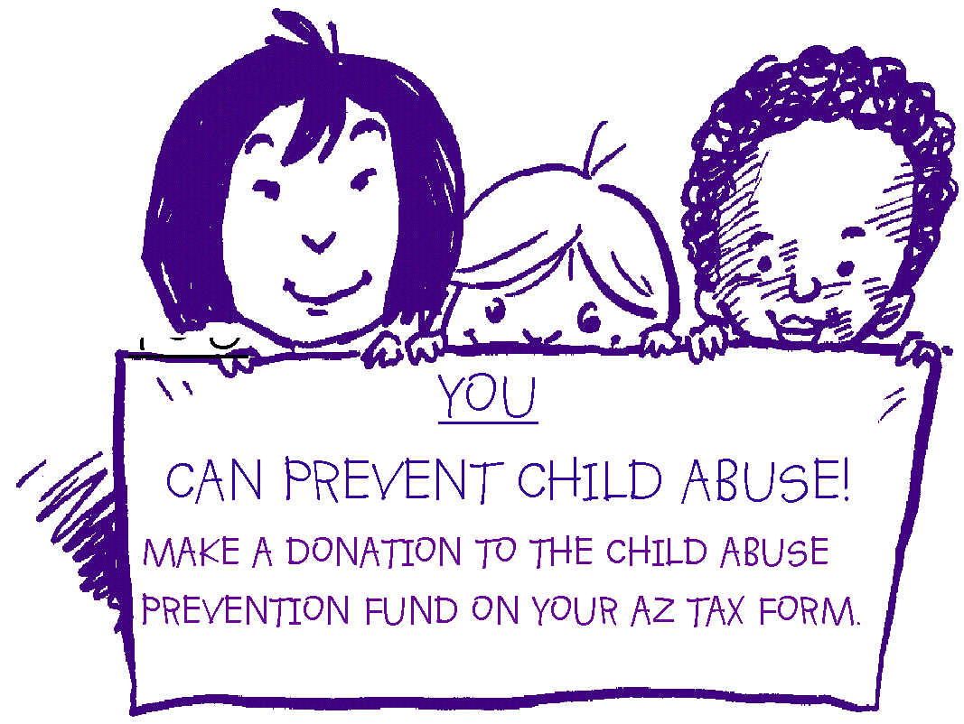





**E-MAIL:**

Below is a short message that can be sent to anyone via e-mail. Please send to everyone you know in Arizona and ask each recipient to forward it to everyone they know in Arizona.

Please keep track of all e-mails and report your progress on your quarterly report.

**MESSAGE:**

YOU can prevent child abuse. It’s as simple as making a donation to the Child Abuse Prevention Fund on your Arizona Income Tax Return:

Give A Little. Help A Lot!

Please pass this message on so others can help in the fight against child abuse.