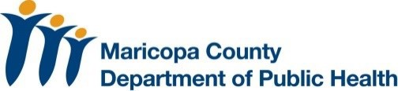
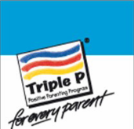
Positive Parenting Program
Seminar Series

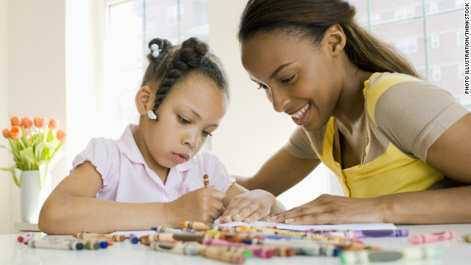

You are the expert on your own family!

Come by our seminars to learn more about Triple P Positive parenting:

The Power of Positive Parenting 10am Monday, April 4th, 2016
Burton Barr Central Library
Lecture Room- 4th Floor
Raising Resilient Children 10am Monday, April 11th, 2016
Burton Barr Central Library
Lecture Room- 4th Floor
Raising Confident & Competent Children 10am Monday, April 18th, 2016
Burton Barr Central Library
Lecture Room- 4th Floor

*For more in-depth information on positive parenting, also check online to sign up for our small group sessions.

Location: Burton Barr Library
10am – 12pm in the Lecture room
1221 N. Central Ave.
Phoenix AZ, 85004
Online class summaries and small group sign up: http://www.phoenixpubliclibrary.org/

